1. INTRODUCTION

Oxygen is an important element for human body functions such as metabolisms, respirations and immunity etc. Many clinical diseases are caused by the lack of sufficient oxygen supply, which will affect the normal metabolism of cells [1]. Operation rooms (OR) and intensive care units (ICU) require a continuous oxygen concentration monitoring system, and real-time monitoring of oxygen concentration in blood is an important health check item.

Since 1986, pulse oximeters have been the standard of care for monitoring the oxygen concentration of blood to ensure health and safety of patients [2]. Through the use of a pulse oximeter during an operation, the anesthesiologist ensures that oxygen is sufficiently delivered to the tissue during mechanical ventilation [3]. After the successful deployment of the pulse oximeter in the Operating Room (OR) and Intensive Care Unit (ICU), it is currently being widely used in other hospital units and patient clinics as well. Medical professionals believe that arterial SpO2 measured by pulse oximetry, will be the fifth vital sign for human [4], as we previously reported the clinical potential for monitoring hemodynamic changes of the acute scrotum [5].

Here SpO2 is the ratio of oxyhemoglobin in the red blood cells to total hemoglobin, representing the body's ability to carry oxygen. Currently, there are two methods for measuring SpO2. The first method is to draw blood from arteries and then use a blood gas analyzer [6] to perform electrochemical analysis [7] for the determination of the partial Pressure of Oxygen (PO2) which is then converted to the peripheral capillary oxygen saturation (SpO2).

Although blood gas analyzer can determine the exact value of oxygen level in the blood, it uses invasive needles to draw the blood from arteries, and thus it cannot perform continuous monitoring of blood oxygen level. Also, it is time-consuming. Furthermore, the cost is high and requires a trained medical professional to perform the test, and hence it can only be performed in the hospitals.

In the second method, sensor is placed on the point/area of intent and two light signals with different wavelengths are produced using a pair of Light Emitting Diodes (LEDs). These signals pass through the blood vessels of human tissue simultaneously, and the detectors receive the reflected signals from the blood. The ratio of the intensities of the two reflected signals with different wavelengths are then calculated and converted to SpO2 via a lookup table [8] based on the Beer-Lambert law [9].

While there are many such commercial oximeters available, their limitations can be summarized in Table 1 with their respective reported solutions. All these limitations produce errors in determining the accurate level of SpO2 which can be overcome by the reported solutions. However, among them, there are two limitations which remain unnoticed, namely the light scattering property of LED and measurement of low SpO2 level.

Available oximeters in the market commonly use LEDs for detection of SpO2, Due to light scattering effects in LED, signal loss or decrease in the signal to noise ratio (SNR) occurs that causes inaccuracy in the measured SpO2. Detection of low SpO2 (< 94%) depends on the low-intensity reflected pulse signals, thus its error can be high, and its measurement time is also very long in order to gather sufficient signal information using pulse oximeter. On the other hand, detection of low SpO2 level is crucial since it indicates abnormal situation in our body.

TABLE I Limitations and their reported solutions for the commercial oximeter

|  |  |  |
| --- | --- | --- |
| **S/No** | **Limitation and Causes** | **Solution** |
|  | Motion Artifacts: Due to the muscles movement during measurement [10]. | Retrospective motion correction technique is employed at the post-process phase using algorithms to eliminate this limitation [11]. |
|  | Ambient Light: Interference of the ambience light by the photodiodes during measurement [12]. | A logarithmic amplifier is added in the signal-processing circuitry to subtract the signal components of ambient light or background light from the received signals [13]. |
|  | Skin Pigmentation: Presence of dark skin pigmentation [14]. | It can be solved by ‘Munsell color tile system’. In addition, human observation is also required [14]. |
|  | Abnormal Hemoglobin Molecules: Detection of the compounds like abnormal hemoglobin or methemoglobin [15]. | It can be eliminated by using a ratio of the first derivative of the first two absorbances of hemoglobin and oxyhemoglobin [15]. |
|  | Light scattering property of LED: LED light scattered due to its characteristic of low power and large divergence angle. | Not reported yet. |
|  | Inability to measure the low SpO2 level: signal from low SpO2 become very weak and the background noise can be stronger than the signal. | Not reported yet. |

In this work, a new methodology is developed to address the two aforementioned un-resolved limitations of oximeters. The proposed methodology is described in the following section.

2. OXIMETER DESIGN METHODOLOGY

Hardware design includes the designing of oximeter sensor head for transmission of signals. The reflected signals are captured using detectors and the corresponding analog signals are converted to discrete signals for further computation using Arduino pro mini driver circuit. These discrete signals are first filtered using our developed algorithm on MATLAB platform, followed by the computations of SpO2 and pulse rate. Graphical User Interface (G.U.I.) is designed in the software design path to show the measured SpO2 level and heart rate. Fig. 1 shows the flow of the oximeter system that is developed in this work.

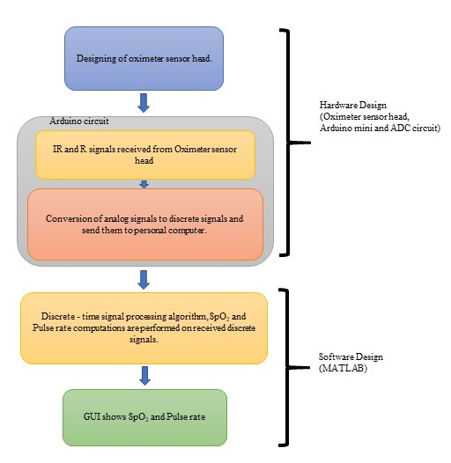

Fig. 1. Research methodology flow chart.

2.1 Hardware Design

The hardware module can be divided into sensor and circuit modules as shown in Fig. 2.

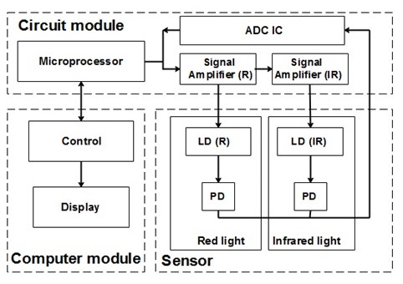

Fig.2 Hardware architecture of oximeter.

The sensor module is a custom-made oximeter sensor probe head fabricated using 3D printing as shown in Fig. 3(a), and it consists of Red (R) and Infrared (IR) light laser diodes (LD) and two photodiodes (PD) placed at a distance from the LD as computed from the optical reflection path. Laser diodes are used so as to eliminate the issue of light scattering in LEDs. For safety consideration, the laser diodes (LD) are low power and it is pulsing so that maximum laser light intensity incident on human tissues are keep within the acceptable limit (20mW to 40 mW) with limited maximum pulsed current for the LDs [16].

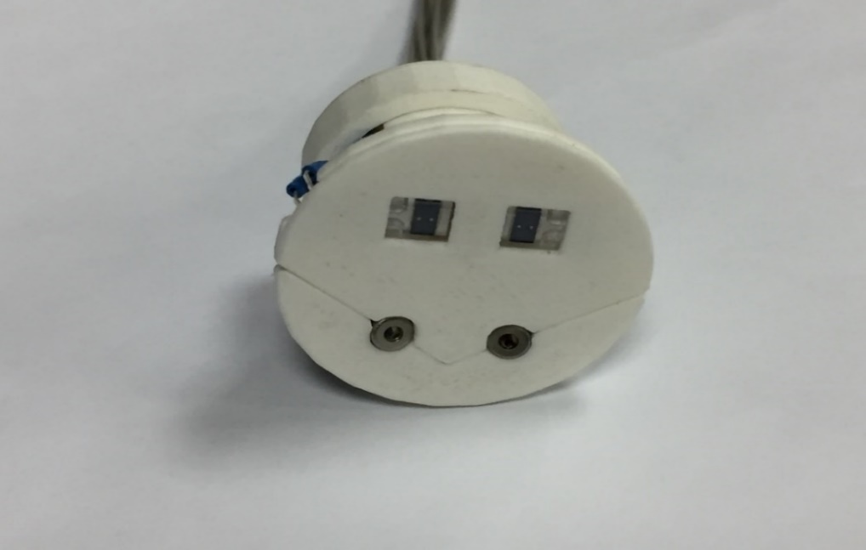

Photodiodes

IR laser

R laser

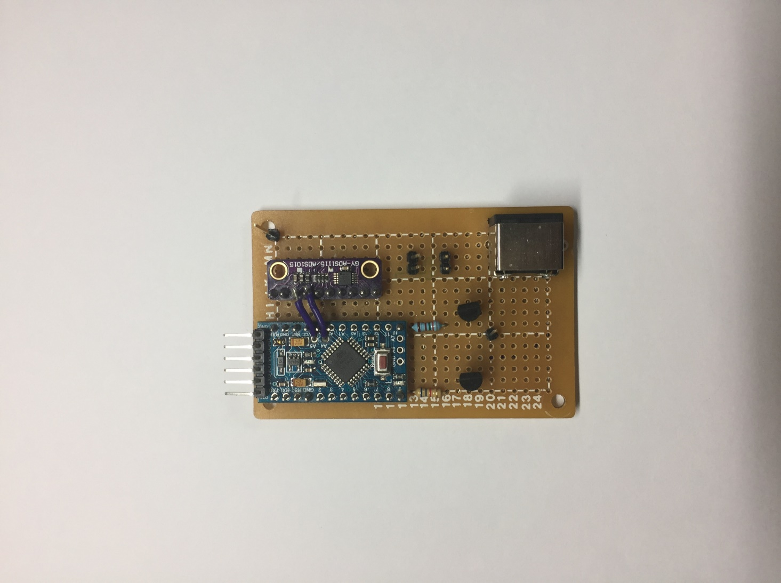

(a)

(b)

Fig. 3 (a). Oximeter sensor’s probe head, (b). Arduino driven circuit for SpO2 measurement

Fig. 3(b) shows the circuit module that consists a microprocessor (Arduino pro mini), analog to digital converter IC (ADS1115/ ADS105) and transistors. Arduino pro mini microprocessor is used for controlling the emissions of IR and R laser diodes, and the photodiodes are to receive the reflected IR and R signals. Conversion of the received analog signals into the discrete signals is done using analog to digital converter (ADC) IC. These converted signals are then sent to the Microprocessor for discrete time signal processing (DTSP).

2.2 Software Design

Fig. 4 shows the signal processing algorithm for DTSP, and it consists of three principal steps as explained below.

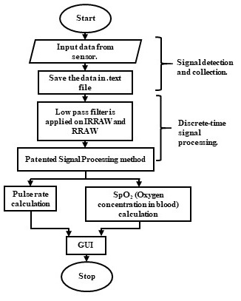

Fig. 4 Signal Processing Algorithm for calculating SpO2, using raw reflected signal from Infrared Laser diode (IRRAW) and Red Laser diode (RRAW).

Ideally, the reflected signal should be as shown in Fig. 5(a), where the peak and valley of the waveform is used for the computation of heart beat and SpO2 [12]. In actual case when SpO2 is above 94%, the reflected waveform does resemble the ideal case as shown in Fig 5(b). However, when SpO2 goes below 94%, as in the case where we intentionally depressed the volunteers’ arm to limit the blood flow, the expansion and contraction of the blood vessel walls become very small. Since the detection of the SpO2 is based on the expansion and contraction of the blood vessel walls [12], the signal becomes very weak, and the signal to noise ratio is so small that useful signal cannot be extracted as shown in Fig 5(c). Thus, a special signal processing method has to be developed and the first step in the processing of the saved discrete signals is to filter the noise.

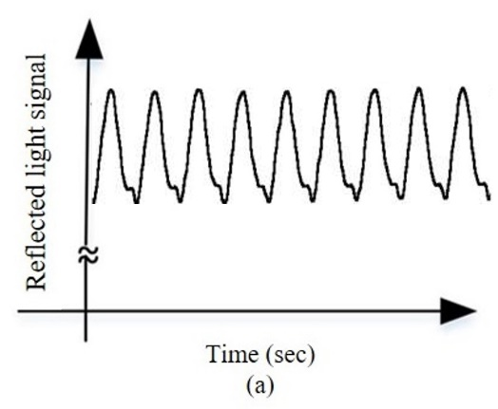



(b)



(c)

Fig. 5. (a). Ideal reflected from arteries [17], (b). Reflected IRRAW light signals during experiment without depressing the volunteers’ arms, (c) Reflected IRRAW light signals during experiment with depressing the volunteers’ arms

The setting of the filter is done through Fourier analysis of the signals implemented using the Fast Fourier Transform (FFT) in MATLAB. The noise peaks are found to be prominent after 9 Hz in IRRAW and RRAW signals, as shown in Fig. 6 (a) and (b) respectively.



(b)



(a)

Fig. 6. (a) FFT of the IRRAW signal, (b). FFT of RRAW signal.

To filter out these noise peaks, a low pass filter with the cut off frequency of 9 Hz is applied on the received signals, followed by a mathematical function as shown in Fig. 7.



Fig. 7. Mathematical function applied on (a) IRRAW vs time (sec) and (b) RRAW vs time (sec)

Using the filtered and processed IRRAW and RRAW signals, heartbeat computation is done using Eq. (1). As illustrates in Fig. 8, the detection of peaks and valleys are first done using MATLAB, and the time interval between the consecutive peak and valley is calculated.

|  |  |
| --- | --- |
|  | (1) |



Fig.8. (a) IRH (peak in IRRAW curve for every second) and IRL (valley in IRRAW curve for every second) detection. The time interval between two peaks (IRH) is bn. (b) RH (peak in RRAW curve for every second) and RL (Valley in RRAW curve for every second) detection.

The calculation of the SpO2 is done using Eq. (3) [18], with the help of Ros (ratio of ratios) [18].

Ros is a variable calculated by taking the natural logarithm of the ratio of the peak and the valley of the red signal, which is further divided by the natural logarithm of the ratio of the peak and valley of the infrared signal, as shown in Eq. (2) [19].

|  |  |
| --- | --- |
|  | (2) |
|  | (3) |

In Eq. (2), is the extinction coefficient of red light for reduced hemoglobin, is the extinction coefficient of infrared light for reduced hemoglobin, is the extinction coefficient of infrared light for oxyhemoglobin and is the extinction coefficient of red light for oxyhemoglobin. These values are obtained from Fig.9 for the wavelength of the red light (660nm) and infrared (850 nm) LDs used. These wavelengths are measured using Integrated sphere of model LM-ISP 3.4. , are obtained from Oxyhemoglobin curve and , are obtained from Reduced hemoglobin curve. The narrow chromatic spread of the laser diodes also helps in providing more accurate extinction coefficients for the calculation.

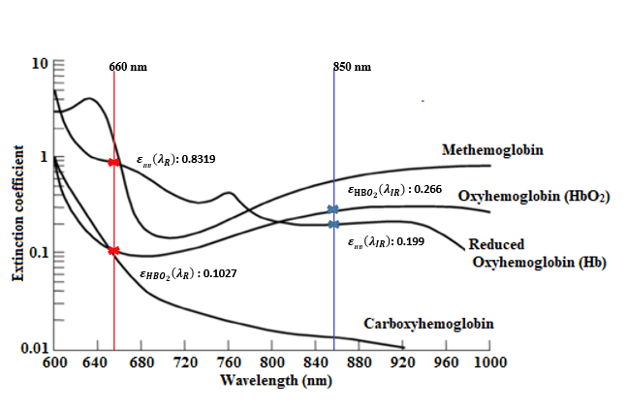

Fig. 9. Extinction coefficients , , and vs. different light wavelength in human blood [17].